GP2 Coursework
Games Programming 2
BMADIN200 – S1507379
Ben Madine

I confirm that the code contained in this file (other than that provided or authorised) is all my own work and has not been submitted elsewhere in fulfilment of this or any other award.
Ben Madine

Contents
Class Descriptions
- Camera Manager Page 3
- Game Display Page 4

- Audio Manager Page 6

- Mesh Manager Page 6

- Shader Manager Page 8

- Texture Manager Page 10

- Transform Manager Page 11

- Game Manager Page 11

Resource Files
- Fog.frag Page 16

- Fog.vert Page 16

- Shader.frag Page 16

- Shader.vert Page 16

- Appendix and Side Notes Page 17

Class Descriptions

This report will discuss and explain the various header and source files used in this project. These files made a game similar to space invaders.

Camera Manager Class
The camera manager class instantiates a camera which allows the game to be seen. To do this the InitaliseCamera method is used. This method takes in five different arguments. These arguments are: the camera position, field of view, aspect ratio, the near and far clipping planes.
In addition to creating the camera this class also has the camera movement methods: MoveForward, MoveBack, MoveLeft, MoveRight. These methods allow the camera to move in a desired direction. In Figure 1.0 the code will be shown:
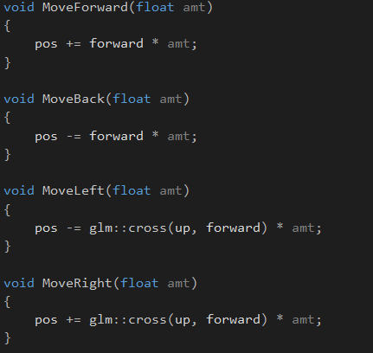

Figure 1.0

As Figure 1.1 demonstrates. Each of the movement methods take in a float, amt (amount). The MoveForward and MoveBack methods are very similar, only with one difference. This difference is that the forward movement is being taken away from the camera’s position in the MoveBack method whereas the MoveForward method, the forward movement is being added to the camera’s position. The MoveLeft and MoveRight methods are also very similar. The difference between these two methods is the cross-product sum is taking or adding to the camera’s position.

Game Display Class
The GameDisplay class creates the window. The header file contains four methods: initialiseDisplay, bufferSwitch, displayClearer, returnError. The initaliseDisplay method creates the display while the displayClearer clears the display by taking in four float arguments. The bufferSwitch method swaps out the buffers. The returnError method is used for debugging purposes and checks if there was anything wrong when the display was created.
The Display Class source file uses these methods. In the Game Display constructor, the width and height of the screen is set whereas in the destructor the game window is destroyed, and the application is closed.
After the constructor and destructor methods ‘getters’ are used which return the width and the height of the screen.
Further through the code the returnError method is used, which takes in a string argument. This method simply displays a message in the console window and then quits the application when a key is pressed. This method is called in the initaliseDisplay method.
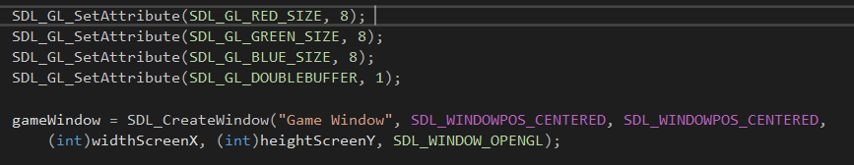
The initaliseDisplay method creates the game window setting red, green, blue attributes as well as setting up the double buffer. The code will be shown in Figure 2.0:
Figure 2.0
As Figure 2.0 highlights the red, green and blue attributes are given a value of eight because that is the minimum number of bits used to display colour. In addition to this the double buffer is created. A double buffer is used to eliminate on screen tearing. Shortly after the double buffer is created the game window is actually created. The game window takes in six arguments: the window name, the position of the window in the x axis, the position of the window in the y axis, the width of the screen, the height of the screen and finally SDL_WINDOW_OPENGL, which allows the window to use openGL.
After this, error checks are then in place. If there is a problem with the window, then the returnError method is called. These errors can be seen in Figure 2.1:
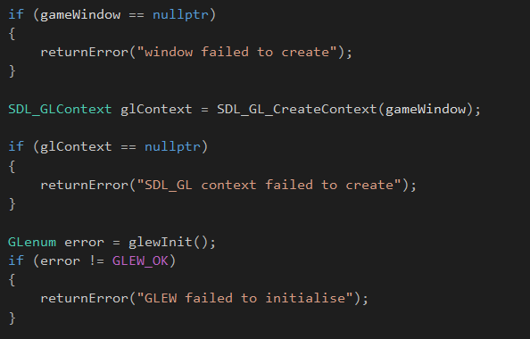

Figure 2.1

As Figure 2.1 shows, the first error check is to see if the game window is equal to null. This means that the window does not exist. If so then the return error method is called. The next error check is to determine if the glContext is not null. SDL_GLContext simply creates an OpenGL context for the OpenGL window to use. The last error is to check if the Glew library has been created.

Audio Manager Class
The audio manager class handles all aspects of the code that manage the different aspect of the audio files. In the AudioManager header file there is two struct data structures: Data and Vector3. The data struct contains all the information about the audio file, such as: sourceID, bufferID, the buffer and the name of the audio file. Whereas, the vector struct contains three floats: x, y, z.
The AudioManager class also contains a number of methods. These methods are: deleteSound, playSound, stopSound and setListener. These are all called in the AudioManager source file.
The AudioManager constructor checks for errors by checking if the sound card and the audio context cannot be accessed. The AudioManager destructor contains a ‘for’ loop which runs for the size of the data. Inside this for loop the audio is deleted. After the for loop has finished the audio context is destroyed and the audio device is closed.
The next method ‘isBigEndian’ is used to read the sound data properly from the audio file. Further on there is the conversion method, convertToInt. This method converts a char array to an integer array. This is needed because OpenAL uses integers as its parameters whereas some of the WAV sound data is stored as char.
After the conversion method the sound audio file and sound are loaded as well as the methods which delete, play and stop the sound. In addition to these methods the setListener method is processed. The set listener method places an audio listener in the world and faces it towards the camera.

Mesh Manager Class
The MeshManager class contains two different struct’s and one other class. The two structs are: VertexManager and SphereCollider. The class is MeshManager.
The VertexManager struct contains the different vectors such as the: position, texture position and the normal. In addition to this there is a VertexManager method which takes in three different arguments: a vector3 position, a vector2 texture coordinate and a vector3 for the normals. The position is the coordinates of the mesh whereas the texturePos is the position of the texture. The norms are the normal’s which are part of the mesh.
Moving on to the SphereCollider struct. This struct is used when detecting collisions. It does this by creating a circle around the mesh and checking when an object enters the circle’s radius. This struct contains two different variables: a float, circleRadius and a vector3, the position of the circle.
The class MeshManager contains multiple methods which instantiate and draw the model. The initialize method contains two separate ‘for’ loops. The first ‘for’ loop adds all the vertices to three separate lists: position, texCoords and normal. These lists allow the mesh to be displayed in the correct format. The second ‘for’ loop is used to add indices to the indices list.
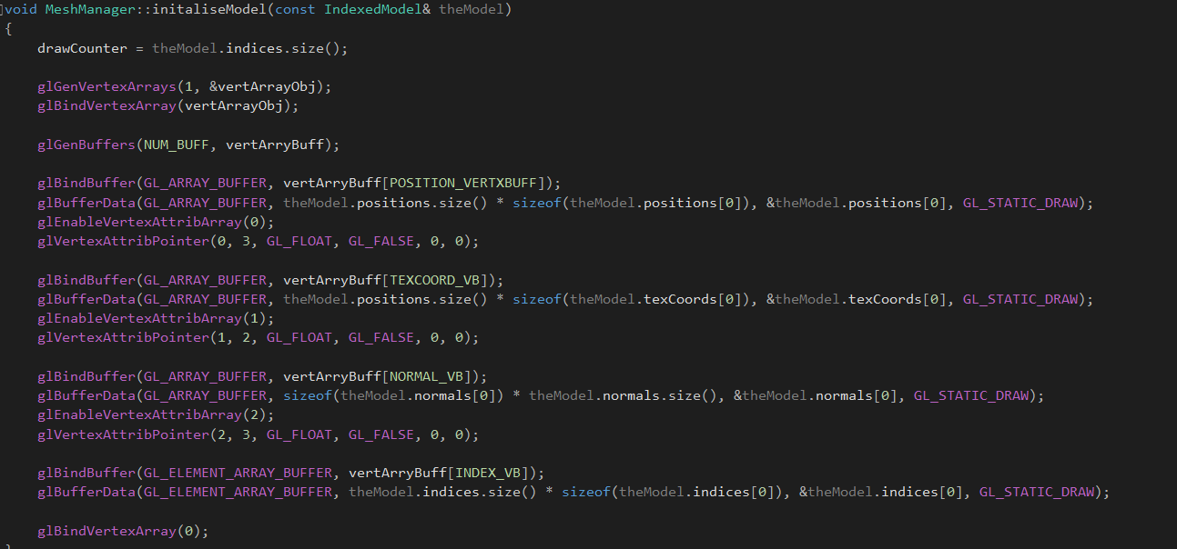
The initaliseModel method contains the separate buffers that draw the model, which can be seen in Figure 3.0:
Figure 3.0
The separate buffers in Figure 3.0, create arrays which hold certain types of data for the mesh. Once the array has been established the information is sent to the graphics card. ‘glEnableVertexAttribArray(i)’ assigns an array to the correct array position.
The modelLoader method loads the model from the file and calls the sphereMesh method from the SpherCollider struct. The Drawing method draws the separate triangles which make up the actual model. Further on down the code the sphereDataUpdate method is being processed. The method allows the position of the model and the radius of the collider to be updated once this method is called.

Shader Manager Class
The ShaderManager Class is used to load the shader’s from the resources and apply them to the models. The ShaderManager class contains multiple methods, these being: initShader, Bind, Update, LoadShader, CheckShaderError and CreateShader. In addition to these methods an array is used to hold the multiple shaders and another array is used to hold the number of uniforms.
In the ShaderManager source file the initShader method is processed first. From Figure 4.0, it is clear that there are separate shaders. Figure 4.0:
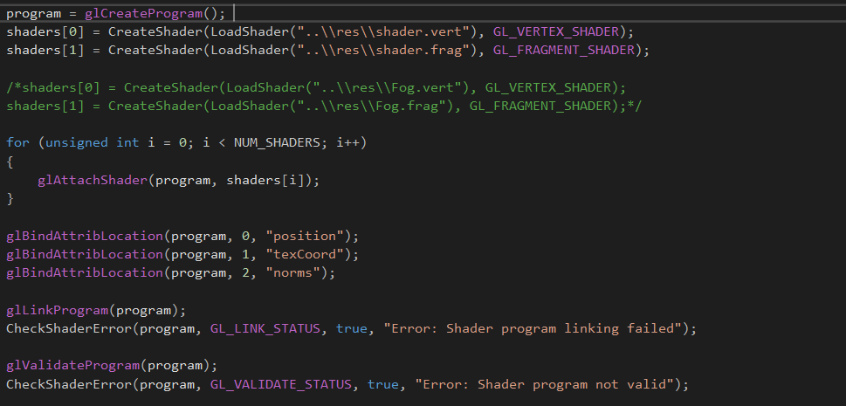
Figure 4.0
Inside this method the separate shaders are created. Firstly, the shader program is created which then leads on to the vertex and fragment shaders being created. The ‘shader.vert’ and ‘shader.frag’ is used for the models Once the shaders have been created they are added to the shader program. The next part of the method is to associate the selected variable with the correct shader program, in this projects case the position is allocated to zero, the texture coordiantes are allocated to one and the normals are allocated to two. The normals where added to the code to allow the fog to work. After the shaders have been allocated to the shader program executables are created that will run on the GPU additionally when one is created an error check is in place which displays a message to the console if any errors occur. As well as this another check is in place which ensure the entire program is valid.
The Fog Shader method is used to create the fog inside the game. This fog shader method can be seen in Figure 4.1: 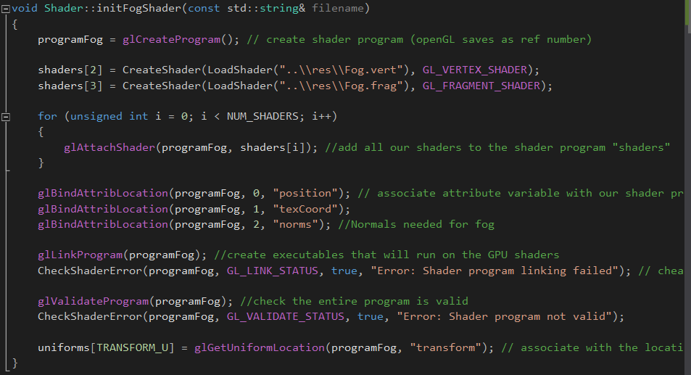
Figure 4.1
Figure 4.1 shows the the fog shader method, this method is almost identical to the initatlise shader method. It loads the fog vertex and fragment shader. Unfortunatly the fog shaders arent working due to a linking error.

Texture Manager Class
The texture Manager class binds the textures to the models as well as creating the skybox. The texture manager header file contains three methods: TextureManager, ~TextureManager,TextureSkyBox and Binder.
The TextureManager constructor takes in a string argument which is the file name of the texture. Inside this method the image data is assigned. The image data consists of the file name, width, height and the number of components. An error check is then in place that checks whether the image data does not exist. If the image data does return null, then a message is displayed to the console. The next part of the code identifies the address of the textures and binds the texture. Once the textures have been bound the texture is now wrapped outside both width and height. The next part of the code is to check if the texture is smaller or larger than the model. Further down the code, the texture is then sent to the GPU to be processed and is deleted from the CPU.
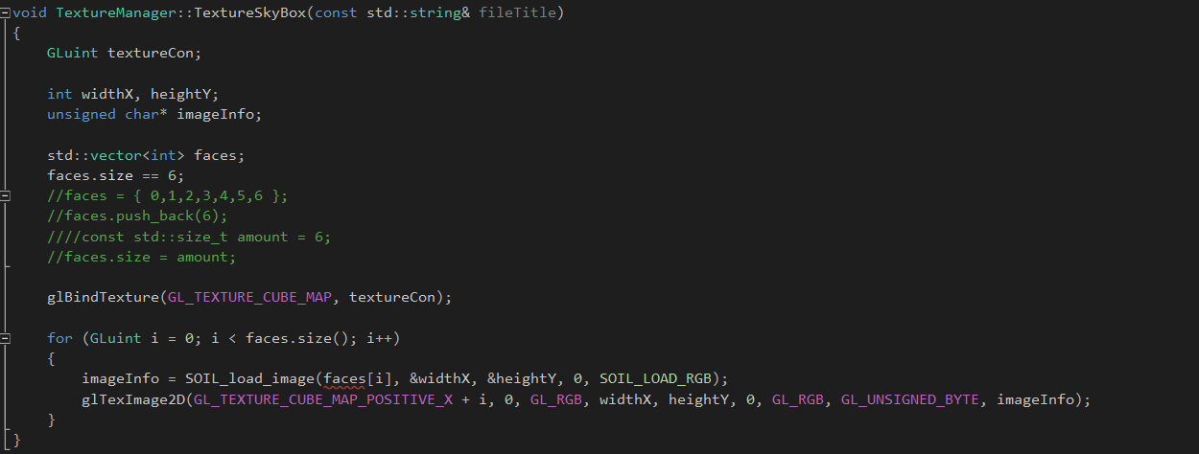
The TextureSkyBox method is being used to generate the skybox. One other issue with the code is the skybox method. The issue with this method is that there is a casting error when trying to load the different image faces into the image data. This can be seen in Figure 5.0:
Figure 5.0
As Figure 5.0 highlights, there was multiple ways which the code tried to overcome this error. Originally the code was simply using ‘puch_back (6)’. However, the reason why this never worked was because ‘push_back’ will not actually push 6 elements which was wanted but in fact will put 6 elements in one variable. To solve this first issue the list was changed to a vector which allowed a manual input of the size but that also never worked. If the code had have worked then the ‘imageInfo’ variable would then be used to specify the skybox texture image. Using a ‘for’ loop to do this code meant that a more efficient method could be used rather than inputting all 6 faces manually. This can be seen when ‘GL_TEXTURE_CUBE_MAP_X + i’. However, the second attempt at the skybox was done by using a separate technique. This can be seen further on in the report in the Game Manager Class.
After the sky box method, the Texture Manager destructor is used to delete the textures and Binder method sets the appropriate texture to become active and then binds that texture.

Transform Manager Class
The transform manager class is used to calculate the movement, scale and rotation of the models. This header file does this using three different variables: position, rotation and scaler. In this header file there are getter’s and setter’s which allow other class’s, game manager class, to retrieve these attributes from the models and change them in any way.
Game Manager Class
The game manager class is the main bulk of the project with the header file including most of the other headers. The header file contains multiple methods along with multiple different variables, ranging from the different game states, meshes, textures, shaders, the camera, floats, integers, audio devices and Booleans.
The Game Manager source file begins with the constructor and automatically sets all collision to false to stop objects from being destroyed at the start. Once this has been achieved the game state is set to ‘PLAYING’. With the game state set to ‘PLAYING’ the other methods start to run, only once the loopingGame method is called. Shortly after the game state has been assigned various pointers are set, to the Game Display class, Audio Manager class, Mesh Manager class and the Shader Manager class.
The next method to be processed is the initaliseSystem method. This method assigns all the correct sounds to the correct variable names, the multiple shaders, the various models, initialize the camera and the game display. When creating the multiple aliens, a ‘for’ loop had to be used to load in the ten separate models.
Once the initaliseSystem method is processed the loopingGame method is next. The loopingGame method consist of a ‘while’ loop that constantly checks if the game state does not equal quit. Inside this ‘while’ loop there contains two methods and the background music which constantly plays and a ‘for’ loop which check all the collision’s in the game. The two methods are inputProcess and drawingGame.
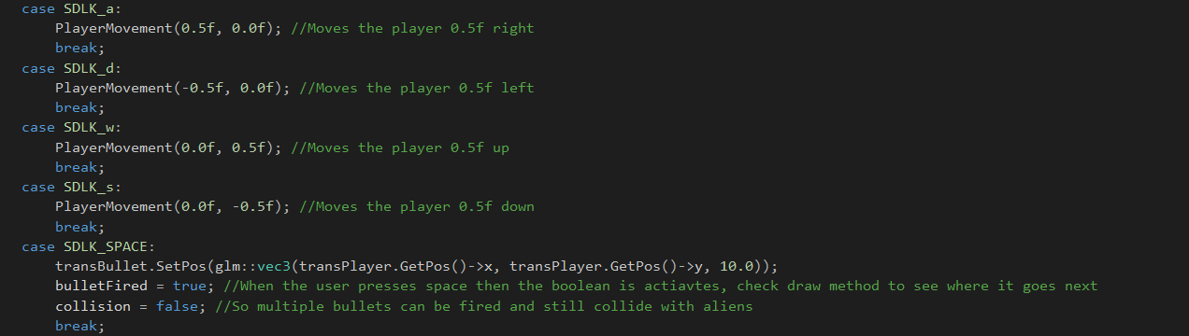
The inputProcess method simply register key presses and depending on what key is pressed a specific action occurs. These actions can be seen in Figure 6.0:
Figure 6.0
In Figure 6.0, the player’s movement can be seen. Depending on what key is pressed a value will be added or subtracted from the original player’s decision. The player’s movement method will be discussed in more detail further on. Additionally, when the player uses the space key the ‘bullet fired’ variable is set to true and the collision is set to false. The next set of key inputs control the camera’s position which will be shown in Figure 6.1:
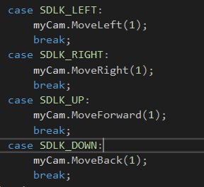

Figure 6.1
As Figure 6.1 highlights the arrow keys are used to move the camera in certain direction by a value of one.
Further down the game manager source file the colliderChecker method is being processed when a collision occurs. This method takes in four arguments, a vector for the circle position and a float for the circle radius, for both objects which collide. A calculation is used which determines the distance between the two circles and if the distance is less than the sum of the two radii added together then the collision equals true.
Further on the player’s controls and actions methods are being used. The players actions are split up into three different methods. These methods being: BulletManager, PlayerMovement and PlayerManager.
The bullet manager method is in charge of the drawing the model, moving the model and checking if a collision has taken place. The bullet method is in Figure 6.2:
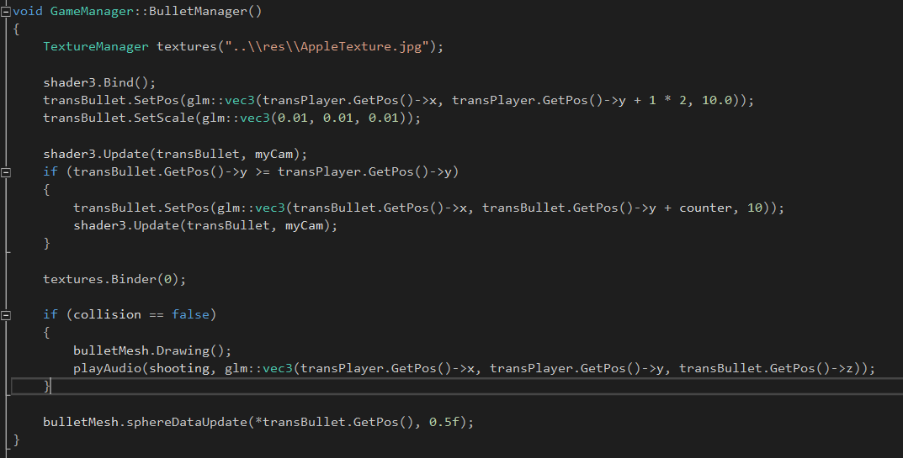
Figure 6.2
As Figure 6.2 highlights, the texture for the bullet is allocated first and then the shader is bound. After this the bullets position is set to be on top of the player. This is because the bullet is supposed to spawn on the player and then move up from that position. The next line of code updates the bullets position and uses an ‘if’ statement to allow the bullet to continually move up. Once this has been processed the appropriate texture is bound. In this case the texture is zero. Further on through the code the collision checkers occurs by using an ‘if’ statement. In this ‘if’ statement, the bullet mesh is continually drawn, and the shooting audio is played until the collision is equal to true. In order for the collision to work properly a ‘for’ loop had to be used which ran through all the possible alien colliders to check what alien was actually hit. Additionally, at the end of this method, the bullet models, collider is updated to the bullets position as well the radius of the collider.
Moving onto the PlayerMovement Method. This made takes in two arguments: float ‘i’ and float ‘k’. Float ‘i’ is used for the transition across the X axis whereas ‘k’ is used for the transitions across the Y axis. As show before in Figure 6.0, when a key is pressed a value is given to either ‘i’ or ‘k’ which allows the player to move. Additionally, this method also resets the players position if they move out of bounds. When the player moves past the designated border they are moved to the other side of the screen. This can be seen in Figure 6.3: 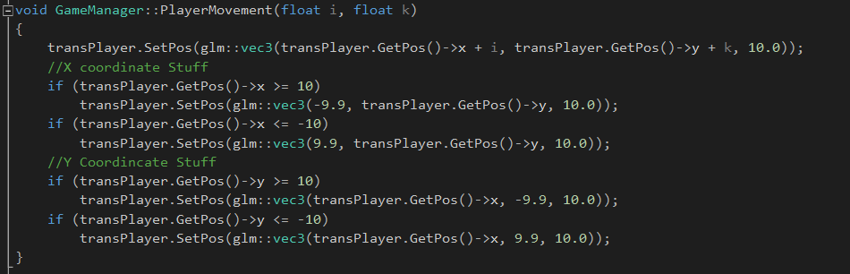
Figure 6.3
Finally, the last part of the player code is the PlayerManager method. This method is similar to the bulletManager method as this is where the player model is drawn, textures are bound and where the players collision checker takes place.
The alien movement and textures are processed in the AlienManager method. To begin with the aliens, have 4 different textures which are randomly given upon starting and change every frame. The main bulk of the alien manager method is inside the ‘for’ loop which has ten iterations, one for every alien. At the start, the alien’s shader is bound and then the position of the aliens is set. To make this project different from space invaders all the aliens position is constantly updating and given a random position in the world rather than keeping in a formation. This can be seen in Figure 6.4:
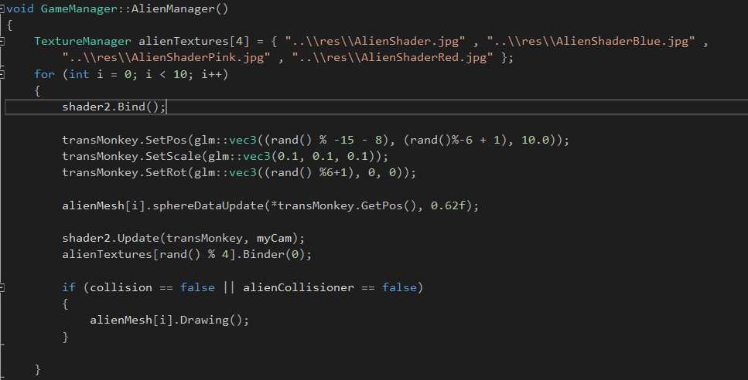
Figure 6.4
As Figure 6.4 shows, the aliens are given a random X position and a random X rotation. This was achieved using the ‘rand()’ function. When checking the collision of an alien, the ‘i’ from the ‘for’ loop had to be used so that the correct alien would disappear when being collided with, also two separate Booleans had to be used to detect whether the player was colliding with an alien or if the bullet was colliding.
The second attempt at the skybox is done in the game manager class. This method had partial success. Doing this technique meant having to input all the faces manually. The partial success leads to all the faces being shown with different textures as a random texture is assigned to each face. In Figure 6.5, the code shows one face getting generated: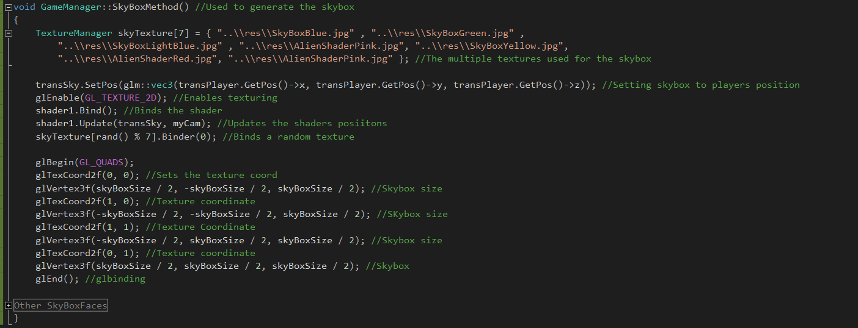
Figure 6.5
Finally, the last method in the game manager is the drawingGame method. This method allows the models to be rendered by using the line ‘glEnableClientState(GL_COLOR_ARRAY). Additionally, this method swaps the buffers to prevent screen tearing and calls both the alien manager and player manager method.

Resource Files

In the resource file there are certain shaders which will be discussed. Firstly, the Fog Shader’s will be discussed.

Fog Vertex and Fragment Shader
The fog vertex shader has two output variables: position and the normals. The main function consists of normalizing the normals by doing the sum of the normal matrix times the vertex normal. This converts the normal to eye coordinates. Additionally, the position is also converted to eye coordinates.
The Fog fragment shader has a lot more components that the vertex shader. The fragment shader uses a distance variable to store the distance from the surface point to the eye position. Additionally a ‘ads’ function is called which stores the shader’s colour. Finally, the main function is called and the colour of the fog shader is mixed with the shader colour stored in ‘ads’. This returns the fragment colour of the fog.
Shader Vertex and Fragment Shader
The vertex and fragment shader have both been edited to allow a light source feature. The fragment shader values allow the light source to affect the models in a different way. In figure 7.0 the light source is clamped between 0.5 and 1 and Figure 7.1 shows the effect at run time: 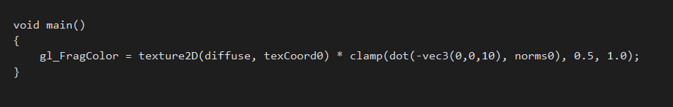
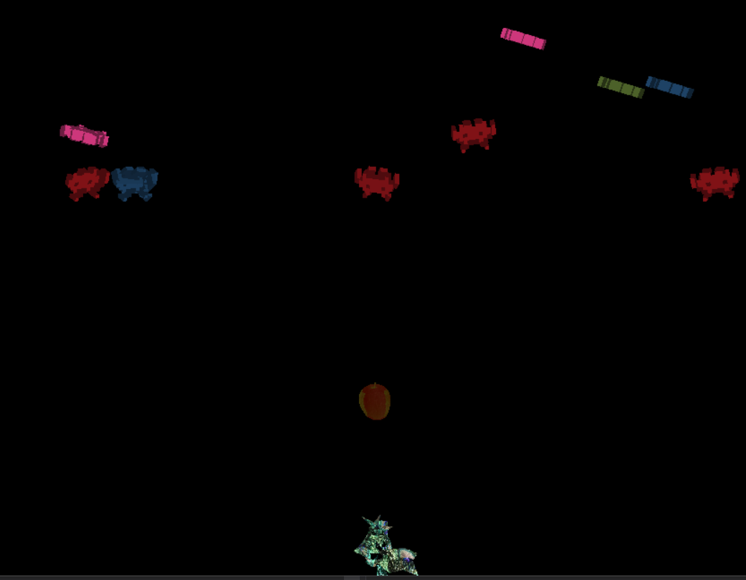
Figure 7.0

Figure 7.1
If the first clamped value is changed to 0.0 there is a noticeable effect on the bullet (the apple). This can be seen in Figure 7.2:
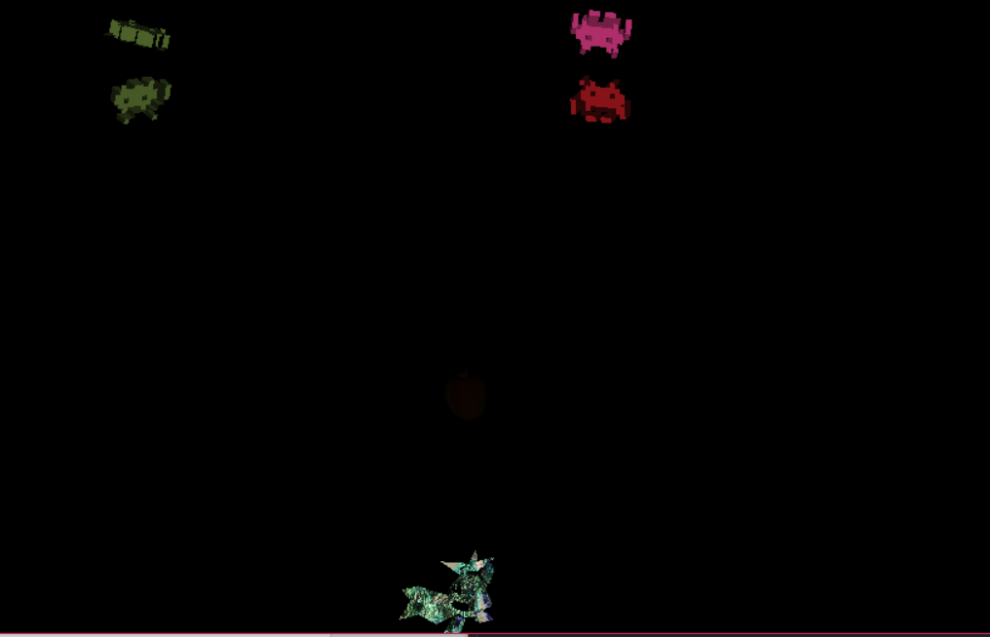
Figure 7.2
The bullet is inside the red box in Figure 7.2.
Appendix
- Random Function: 1, r. (2018). rand() between 0 and 1. [online] Stackoverflow.com. Available at: https://stackoverflow.com/questions/9878965/rand-between-0-and-1 [Accessed 4 Jan. 2018].
- Fog: Blackboard.gcal.ac.uk. (2018). Lecture 9. [online] Available at: https://blackboard.gcal.ac.uk/webapps/blackboard/content/listContent.jsp?course_id=_85518_1&content_id=_2226065_1 [Accessed 4 Jan. 2018].
- Skybox: Blackboard.gcal.ac.uk. (2018). Lecture 10. [online] Available at: https://blackboard.gcal.ac.uk/webapps/blackboard/content/listContent.jsp?course_id=_85518_1&content_id=_2226065_1 [Accessed 4 Jan. 2018].
- Bullet: Turbosquid.com. (2018). 8 bit obj free. [online] Available at: https://www.turbosquid.com/FullPreview/Index.cfm/ID/669803 [Accessed 8 Jan. 2018].
- Alien: Turbosquid.com. (2018). free max model apple. [online] Available at: https://www.turbosquid.com/FullPreview/Index.cfm/ID/549455 [Accessed 8 Jan. 2018].
- Player: Turbosquid.com. (2018). 3D Models for Professionals :: TurboSquid. [online] Available at: https://www.turbosquid.com/ [Accessed 8 Jan. 2018].
- Gun Noise: Freesound. (2018). Laser shoot by MusicLegends. [online] Available at: https://freesound.org/people/MusicLegends/sounds/344310/ [Accessed 8 Jan. 2018].
- Background Music: Freesound. (2018). Teak saxophone sounds like Duduk by iluppai. [online] Available at: https://freesound.org/people/iluppai/sounds/188062/ [Accessed 8 Jan. 2018].
- Alien Death Noise: Freesound. (2018). 06844 mutant dying hit.wav by Robinhood76. [online] Available at: https://freesound.org/people/Robinhood76/sounds/360337/ [Accessed 8 Jan. 2018].
- Textures: Google Images

Side Notes
Player Controls: WASD is for player movement, Space bar is to fire
Camera Controls: arrow keys are used to move the camera

